Problem 2:

2) Use the Langevin Algorithm to do the variational Helium atom case with (in atomic units)
at α = 1.6875

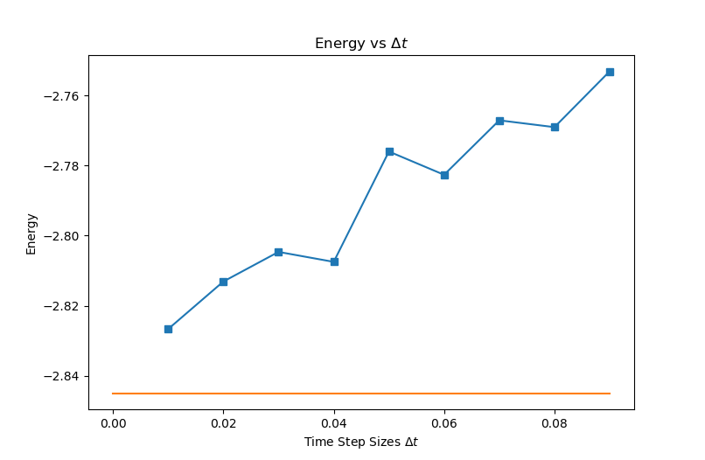
Choose a series of time step sizes such as ∆t = 0.09,0.07,0.05,0.04,0.03,0.02,0.01 etc., until you see the linear convergence

There is a clear trend as the time step gets smaller, the energy approaches the theoretical value linearly.

